COON VALLEY LUTHERAN CHURCH

**“We are a family of God, striving to enrich**

**the lives of all through the love of Christ.”**

PRELUDE MUSIC Mary Schultz

BELLS

WELCOME and ANNOUNCEMENTS

CONFESSION AND FORGIVENESS

Blessed be the holy Trinity, ☩ one God,

our refuge, our delight, our beginning and our end.

**Amen.**

Let us come in truth before the one who loves us

and has freed us from our sin.

*Silence is kept for reflection.*

Eternal One, robed in majesty and mercy, **we confess that sin has taken hold of us** **and we are complicit in its power.** **We are disturbed in spirit and our hearts cannot rest.** **Unbind us and set us free.** **Lead us again to the waters of rebirth,** **that we may live just and generous lives** **for the good of your world** **and the care of our neighbors,** **following in the servant way of Jesus.** **Amen.**

These words are trustworthy and true: Christ bore our sins once, for all, on the cross, swallowing up death forever. For his sake, you are ☩ forgiven and God remembers your sin no more. Let your heart be glad again, and rejoice in your salvation. **Amen.**

GATHERING HYMN #438 My Lord, What a Morning

KYRIE Page 203

Canticle of Praise Page 204

PRAYER of the DAY

Almighty God, **your sovereign purpose brings salvation to birth. Give us faith to be steadfast amid the tumults of this world, trusting that your kingdom comes and your will is done through your Son, Jesus Christ, our Savior and Lord.** **Amen.**

**~ WORD ~** (Scripture insert)

**God speaks to us in scripture reading, preaching, and song.**

FIRST READING: DANIEL 12:1-3

PSALM 16 *(Read responsively)*

SECOND READING: HEBREWS 10:11-25

GOSPEL ACCLAMATION Page 205

***Alleluia! Lord and Savior: open now your saving word. Let it burn like fire within us; speak until our hearts are stirred. Alleluia! Lord, we sing for the good news that you bring.***

The Holy Gospel according to St. Mark the 13th chapter

**Glory to you, O Lord.**

GOSPEL: MARK: 13:1-8

*The Gospel of the Lord.* ***Praise to you, O Christ.***

SERMON

HYMN of the DAY #723 Canticle of the Turning

THE APOSTLES’ CREED Page 105

BLESSING OF THE QUILTS

PRAYERS of INTERCESSION

Petitions end: Merciful God…**Receive our prayer.**

PASSING OF THE PEACE

*Please be aware of those who may not be comfortable shaking hands. You may also fold your hands in front of you and make a slight bow with your head as you say “Peace.” Or any other contactless gesture that you are comfortable with.*

OFFERING & OFFERING SOLO Deanna Wichman

OFFERTORY #186 Create in Me a Clean Heart, O Lord

OFFERING PRAYER

Lord Jesus, our portion and our cup, you offered yourself in love for the world,

and in this meal you nourish us with your life. Fill us with your abundance,

that we may feed the hungry and welcome the stranger, trusting in your name.

**Amen.**

THANKSGIVING FOR THE WORD

O God of justice and love, we give thanks to you that you illumine our way through life with the words of your Son. Give us the light we need, awaken us to the needs of others, and at the end bring all the world to your feast; through Jesus Christ, our Savior and Lord, to whom, with you and the Holy Spirit, be honor and glory forever. **Amen.**

THE LORD’S PRAYER

**Our Father who art in heaven, hallowed be thy name, thy kingdom come, thy will be done, on earth as it is in heaven.**

**Give us this day our daily bread; and forgive us our trespasses,**

**as we forgive those who trespass against us;**

**and lead us not into temptation, but deliver us from evil.**

**For thine is the kingdom, and the power, and the glory,**

**forever and ever. Amen.**

BENEDICTION

The Lord bless you and keep you. The Lord’s face shine on you and be gracious to you. The Lord look upon you with favor and give you peace. ☩

**Amen.**

BELLS

SENDING HYMN #870 We Praise You, O God

DISMISSAL

Go forth into the world in peace; be of good courage, hold fast that which is good; render to no one evil for evil; strengthen the fainthearted; support the weak; help the afflicted; honour all people; love and serve the Lord, rejoicing in the power of the Holy Spirit.

POSTLUDE Mary Schultz

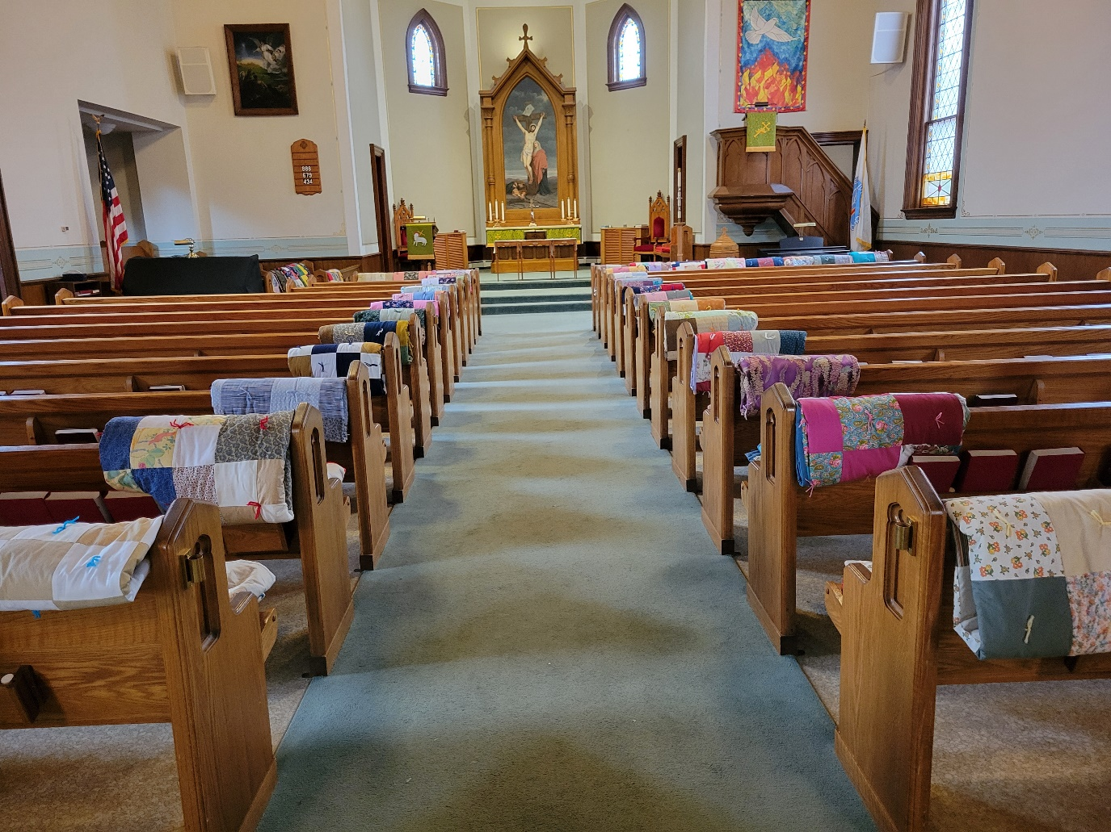

COON VALLEY LUTHERAN CHURCH

THE SEASON OF PENTECOST

BLESSING OF THE QUILTS

November 17, 2024

9:00 a.m.

**~**Bulletins are in honor of the 5th birthday of **Carl Maxwell**!

**~**Thank you to our Quilters, Sunday School & L.I.F.E youth who this year have made 41 quilts to donate to Bethel Butikk and 29 to Sleep in Heavenly Peace!

**Coffee Servers:** Amy Evenstad, Rachel Pederson

**Usher:** Janice Bender

**Reader:** Deb Holen

**Attendance & offering last Sunday:** 142; $4,322.35

**Total Farmers Market 2024:** $1,630.00

**Sunday School Attendance Last week:** 16

Scan this code with your phone to contribute electronically with Vanco.

**SCHEDULE**

**TODAY: 10:15-11:30a/**Sunday School; **10:00a/**Coffee Fellowship; **10:30a/**Confirmation

**TUESDAY: 5:00p/**Worship Committee

**THURSDAY: 10:00a/**WELCA; **6:00p/**Council

**FRIDAY:** Pastor Ben’s sabbath

**NEXT SUNDAY: 9:00a/**Worship; **10:00a/**Coffee Fellowship, Nominating Committee; **10:15-11:30a/**Sunday School; **10:30a/**Confirmation

Remember **"Thumbs Up"**

When you come up for communion if you would like a **gluten free wafer**, give the wafer server a thumbs up as you approach. As you approach the wine server, give him or her a thumbs up to receive **grape juice** instead of wine.

**Coon Valley Lutheran Church**

[**www.coonvalleylutheranchurch.org**](http://www.coonvalleylutheranchurch.org)

**Pastor:** Rev. Benjamin Morris, Office 452-3772/Cell 608-406-1556, [pastor@coonvalleylutheranchurch.org](mailto:pastor@coonvalleylutheranchurch.org)

**Office Administrator:** Jamie Thomas, [office@coonvalleylutheranchurch.org](mailto:office@coonvalleylutheranchurch.org)

**Office Hours: Tuesday, Wednesday, Thursday 9:00a-4:00p**

Office452-3772/Cell 317-0007

**Treasurer:** Becky Lusk, <treasurer@coonvalleylutheranchurch.org>

**Organist:** Mary Schultz

**Indoor Custodian:** Tracy Stellner

**FIRST READING: DANIEL 12:1-3**

“At that time Michael, the great prince, the protector of your people, shall arise. There shall be a time of anguish, such as has never occurred since nations first came into existence. But at that time your people shall be delivered, everyone who is found written in the book. Many of those who sleep in the dust of the earth shall awake, some to everlasting life, and some to shame and everlasting contempt. Those who are wise shall shine like the brightness of the sky, and those who lead many to righteousness, like the stars forever and ever.”

*The Word of the Lord.* ***Thanks be to God.***

**PSALM 16** *(read responsively)*

Protect me, O God, for in you I take refuge.

**I say to the LORD, “You are my Lord; I have no good apart from you.”**

As for the holy ones in the land, they are the noble, in whom is all my delight.

**Those who choose another god multiply their sorrows; their drink offerings of blood I will not pour out or take their names upon my lips.**

The LORD is my chosen portion and my cup; you hold my lot.

**The boundary lines have fallen for me in pleasant places; I have a goodly heritage.**

I bless the LORD who gives me counsel; in the night also my heart instructs me.

**I keep the LORD always before me; because he is at my right hand, I shall not be moved.**

Therefore my heart is glad, and my soul rejoices; my body also rests secure. For you do not give me up to Sheol, or let your faithful one see the Pit.

**You show me the path of life. In your presence there is fullness of joy; in your right hand are pleasures forevermore.**

**SECOND READING: HEBREWS 10:11-25**

Every priest stands day after day at his service, offering again and again the same sacrifices that can never take away sins. But when Christ had offered for all time a single sacrifice for sins, he sat down at the right hand of God,” and since then has been waiting until his enemies would be made a footstool for his feet.” For by a single offering he has perfected for all time those who are sanctified. And the Holy Spirit also testifies to us, for after saying, “This is the covenant that I will make with them after those days, says the Lord; I will put my laws in their hearts, and I will write them on their minds,” he also adds, “I will remember their sins and their lawless deeds no more.” Where there is forgiveness of these, there is no longer any offering for sin. Therefore, my friends, since we have confidence to enter the sanctuary by the blood of Jesus, by the new and living way that he opened for us through the curtain (that is, through his flesh, and since we have a great priest over the house of God, let us approach with a true heart in full assurance of faith, with our hearts sprinkled clean from an evil conscience and our bodies washed with pure water. Let us hold fast to the confession of our hope without wavering, for he who has promised is faithful. And let us consider how to provoke one another to love and good deeds, not neglecting to meet together, as is the habit of some, but encouraging one another, and all the more as you see the Day approaching.

*The Word of the Lord.* ***Thanks be to God.***

**GOSPEL READING: MARK 13:1-8**

As Jesus came out of the temple, one of his disciples said to him, “Look, Teacher, what large stones and what large buildings!” Then Jesus asked him, “Do you see these great buildings? Not one stone will be left here upon another; all will be thrown down.” When he was sitting on the Mount of Olives opposite the temple, Peter, James, John, and Andrew asked him privately, “Tell us, when will this be, and what will be the sign that all these things are about to be accomplished?” Then Jesus began to say to them, “Beware that no one leads you astray. Many will come in my name and say, “I am he!’ and they will lead many astray. When you hear of wars and rumors of wars, do not be alarmed; this must take place, but the end is still to come. For nation will rise against nation, and kingdom against kingdom; there will be earthquakes in various places; there will be famines. This is but the beginning of the birth pangs.”

*The Gospel of the Lord.* ***Praise to you, O Christ.***

*\*We are always so happy to include you and our CVLC family in our prayers. If you feel your name, or the name of a family member can be added or removed from this list please contact Jamie.* *Thank you!*

**We remember in prayer:**

**†** *Those hospitalized this past week*

**†** *Our members whose names we lift up in prayer today:* Corrine Appleman, Beverly Bagstad, Clifford Bakkum, Brian Berg, Pastor Barbara Bruneau, Herby Cornell, Kira Hoff, Becky Ihle, Donna Ihle, Ray Ihle, Verlin Ihle, Todd King, Mike Kellogg, Donald Lee, Margaret Lee, Russell Lee, Aaron Leisso, Colleen Lusk, Aaron Marx, Frank Mathison, Mitzi Miyamoto, LuEtta Nelson,Romaine Nelson, Cathy Ofte, Lisa Olson, Sandra Onshus, Elaine Proksch, Eunice Quast, Lori Roach, Ellen Runice*,* Jojo Satona, Bob Schulze, Mary Schultz, LaVonne Stendahl, Krin (Dreves) Stendalen, Joyce Temp, Debi Thesing, Teri Tomten, Renita Williamson

**†** *Our members who are currently in health care facilities & Assisted Living:*

Tip Bagstad, Inez Beck, Rachel Berg, Carl Daffinrud, Evelyn Dahlen, Jeanne Ebli, Lenore Henley, Carl Holte, Bob Moilien, Betty Nelson, Irene Nestingen, Annie Olson, Beatrice Olson (Alden), Betty Sanders.

**†** *Those who grieve**:* Family and friends of Jim Knutson

**†** *Our members who are currently home bound*

**†** *All those in need of God’s healing and help*

**†** *Family and friends of our members*