**COON VALLEY LUTHERAN CHURCH**

**“We are a family of God, striving to enrich**

**the lives of all through the love of Christ.”**

PRELUDE Mary Schultz

WELCOME & ANNOUNCEMENTS

GATHERING HYMN# 242 Awake! Awake, and Greet the New Morn

ADVENT WREATH LITANY

We have lit the first two candles, one for HOPE and one for PEACE. Today we light the third candle, the candle of JOY. This should be the easy one, because JOY is all around us--in the children, the lights, the music, the gathering together. But how often do we let our preparations--or our memories--push JOY to the side? JOY is like an underground spring that wells up within us, but JOY is also a choice, an attitude. Like a muscle, it needs to be exercised. So today we open ourselves to JOY, trusting that God has already planted it in us...all we need to do is give it care and offer to share.

Loving God, **we open ourselves to you, trusting that this is how you made up: you created us for joy-filled hearts and lives. Show us the creative power of hope. Teach us the peace that comes from justice. Fill us with the kind of joy that cannot be contained, but must be shared. Prepare our hearts to be transformed by you that we may walk in the light of Christ.**

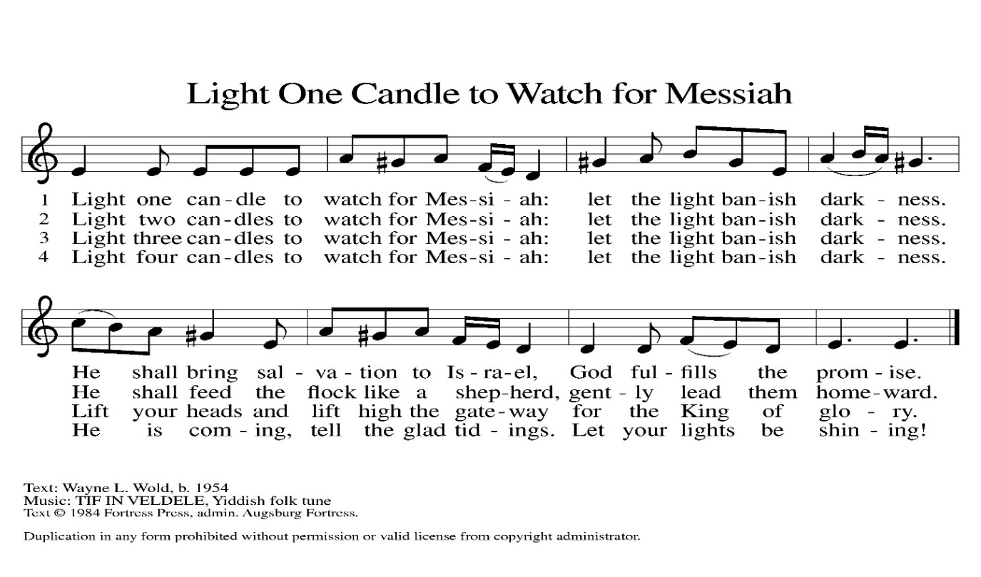LIGHTING OF THE ADVENT CANDLE OF PEACE #240 Verse 1-3

PRAYER of the DAY

Stir up the wills of your faithful people, Lord God, **and open our ears to the preaching of John, that, rejoicing in your salvation, we may bring forth the fruits of repentance; through Jesus Christ, our Savior and Lord, who lives and reigns with you and the Holy Spirit, one God, now and forever. Amen.**

CHILDREN’S CHRISTMAS PROGRAM

**PROCESSIONAL SONG Little Children, Can you Tell?**

Scene 1 Angel Gabriel Appears to Mary

Scene 2 Angel Gabriel Appears to Joseph in a Dream

**Congregation Sings #265 The Angel Gabriel from Heaven Came**

Scene 3 Mary and Joseph Meet

Scene 4 Mary & Joseph Make it to Bethlehem

Scene 5 Part 1 At the Stable Jesus is born

**Song: Away in a Manger**

Scene 5 Part 2 Angels Appear to Shepherds

**Song: One Little Angel**

Scene 6 Wiseman See the Star

Scene 7 Wiseman Meet King Herod

Scene 8 See Jesus

**Song: One Small Child in a Land of a Thousand**

**ACKNOWLEDGEMENTS Maggie Traastad**

PRAYERS of INTERCESSION

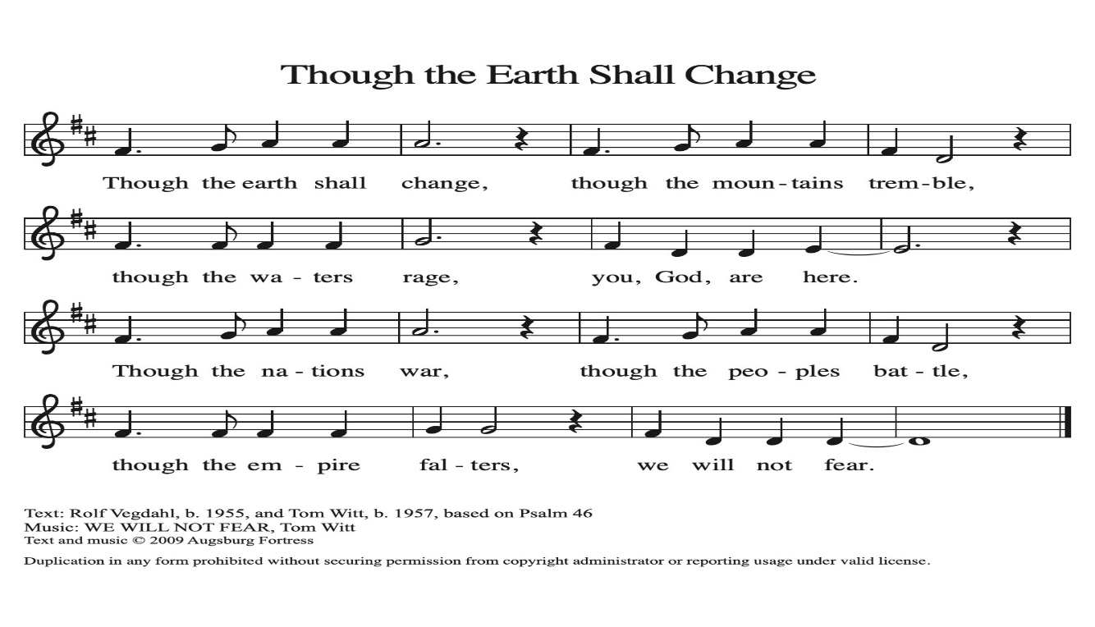Petitions end: Lord in your mercy…congregation to sing the response below

PASSING OF THE PEACE

*Please be aware of those who may not be comfortable shaking hands. You may also fold your hands in front of you and make a slight bow with your head as you say “Peace.” Or any other contactless gesture that you are comfortable with.*

OFFERING & OFFERING SOLO Horse & Sleigh Kristina Thomas

OFFERTORY #186 Create in Me a Clean Heart, O Lord

OFFERING PRAYER

Creator God, **you made the whole world, even the farthest stars,**

**and you draw near to feed us. We praise you for these gifts of bread and wine.**

**Strengthen us with this food that we may live in expectation for the advent of your Son, Jesus Christ our Lord. Amen.**

THE LORD’S PRAYER

BENEDICTION

God of endings and beginnings, God in the darkness and the light, God, our hope for the journey, ☩ bless and keep you now and forever. **Amen.**

BELLS

SENDING HYMN #267 Joy to the World

DISMISSAL

Rejoice in God always, rejoice. For God has created you with the capacity for joy. Trust in God's good will for all of creation and open yourself to God’s gentle, transforming love. Go forth in hope, peace, and joy. **Thanks be to God.**

POSTLUDE Mary Schultz

**With special thanks:**

**Maggie Traastad: Sunday School Coordinator**

**Sunday School Staff: Meghan Maxwell, Josh Maxwell, Amy Stakston-Wiedemann, David Schultz**

**Pianist: Mary Schultz**





**Coon Valley Lutheran Church**

**The Third Sunday in the Season of Advent**

**Children’s Christmas Program**

**December 15, 2024**

**10:00 a.m.**

**~**Bulletins are in honor of Gary Grethel & Julie Nelson’s 30th wedding anniversary!

**Usher:** Barry Bergum

**Attendance & offering last Sunday:** 100; $3,686.61

**Sunday School Attendance Last week:** 15



Scan this code with your phone to contribute electronically with Vanco.

**SCHEDULE**

**TODAY: Giving Tree Gifts due today!**

**THURSDAY: 10:00a/**WELCA Christmas Brunch; **6:00p/**Church Council

**FRIDAY:** Pastor Ben’s sabbath

**NEXT SUNDAY: 9:00a/**Worship; **10:30a/Confirmation; No Coffee Fellowship, No Sunday School; 10:15a/**Intergenerational Trip informational meeting at Middle Coon Valley Lutheran

**Coon Valley Lutheran Church**

[**www.coonvalleylutheranchurch.org**](http://www.coonvalleylutheranchurch.org)

**Pastor:** Rev. Benjamin Morris, Office 452-3772/Cell 608-406-1556, [pastor@coonvalleylutheranchurch.org](mailto:pastor@coonvalleylutheranchurch.org)

**Office Administrator:** Jamie Thomas, [office@coonvalleylutheranchurch.org](mailto:office@coonvalleylutheranchurch.org)

**Office Hours: Tuesday, Wednesday, Thursday 9:00a-4:00p**

Office452-3772/Cell 317-0007

**Treasurer:** Becky Lusk, <treasurer@coonvalleylutheranchurch.org>

**Organist:** Mary Schultz

**Indoor Custodian:** Tracy Stellner

**CVLC Christmas Program 2024 Cast Members**

**Narrator** – Madeline Morey

**Gabriel** – Deanna Wichman

**Mary** – Kristina Thomas

**Joseph** – Dean Maxwell

**Inn Keeper 1** – Leah Williamson or Jocelyn Buros

**Inn Keeper 2** – Winnie Morris

**Angel 1** – Avery Christianson

**Angel 2** – Madalyn Runge

**Angel 3** – Kinley Drath

**Angels 4, 5, 6, & 7** – Jayda Drath, Mireya Kinstler, Elsie Emmart

**Shepard 1** – June Morris

**Shepard 2** – Harrison Buros

**Shepard 3** – Henry Buros

**Star** – Amy Stakston-Weidemann

**Wise Woman or Queen 1** – Karly Thomas

**Wiseman 2** – Carl Maxwell

**Wiseman 3** – Henry Raasch

**King Herod** – Deanna Wichman

**Donkey** – Winnie Morris

**Coon Valley Lutheran Church**

**Announcements for December 2024**

Good morning and welcome to worship!

**~** In the event of an emergency please contact Pastor Benjamin Morris at this number 608-406-1556

**~Offering envelopes are avilable in the Library.** If you are a member and have used your offering envelopes in the last year you will have envelopes available. If you give primarily electronically you may not have envelopes. If you do not find envelopes and would like some or need to know your giving number please contact Jamie.

**~Newsletter help is needed this coming Wednesday Dec. 18 at 10:00am.** Join us for newsletters, coffee and fellowship!

**~Join Pastor Ben on Thursdays, at 10am for Bible Study**.  There will be coffee, probably some sort of treat and good conversation.  Never been to a Bible study before?  No worries, we will be using the upcoming week's readings and Gospel story.  We will begin on **January 9th** and it will be drop in and out friendly. On WELCA Thursday’s we will adjust Bible Study time as needed. BYOB (bring your own Bible), or use a Bible available at the church. 😊

**~GIVING TREE GIFTS** and monetary donations are due **TODAY**. Thanks to all who participated in the Giving Tree this year!

**~Please note office hours during the Christmas season.**The office will be closed Dec. 23-Jan. 3 for our holiday break! The office will resume normal hours beginning Jan. 6. Thank you for this time away with family!

**~The last day to submit offerings for 2024 is Sunday Dec. 29th. Offerings submitted to the office after this day will be included on your 2025 Giving Statement. Thank you for your generosity in 2024!**

**~New Email!** Please note the new email for Pastor Ben and Jamie are as follows:

Pr. Ben: [pastor@coonvalleylutheranchurch.org](mailto:pastor@coonvalleylutheranchurch.org);

Jamie: [office@coonvalleylutheranchurch.org](mailto:office@coonvalleylutheranchurch.org)

Becky: [treasurer@coonvalleylutheranchurch.org](mailto:treasurer@coonvalleylutheranchurch.org)

**~Coon Valley & Middle Coon Valley Lutheran Intergenerational Youth Trip Q & A will be at Middle Coon Valley on Sunday Dec. 22 at 10:15am.** If you are unable to join in this meeting please contact the office for more information.

**~Text message alerts.** If you would like to receive important updates from you church including, service time changes, important events and weather cancellations please text **START to 87447** messaging rates from your cell phone provider may apply.

**~There are several CVLC t-shirts available in the office for purchase.** Contact Jamie if you would like one the cost is $12 or $15 for 2xl sizing.

**~Hearing devices available.** If you need to utilize a hearing device during worship please take one from the table in the entrance and return at the end of worship. If you need assitance with a device please ask an usher.

**~Our Men's Club is selling Kwik Trip CAR WASH cards!**  The cards are $35.00 for 5 washes and can be used at any Kwik Trip car wash!  Please see any Men's Club member or the office to purchase!  Thank you so much for your support!

**~**Please sign up for **Kwik Trip gift cards**. The Youth Mission Trip Fund will get **5%** off the purchase price. Place your order today! Some cards are available today in the office. They make excellent gifts! Contact the office for more information. Please find sign-up sheets in the Narthex and by the office.

**~Bulletin Sponsors.** Sponsoring a weekly bulletin is a great way to honor the memory, birthday, or an accomplishment of someone you love. The cost is $40.00 to sponsor a bulletin. Please sign up on the sheet in the narthex (entrance) or contact the office. **There are several Sundays open for the rest of the year!**

**UPCOMING EVENTS and WORSHIP SCHEDULE—PLEASE JOIN US!**

**Worship Calendar**

**Dec. 22 9:00a/**Worship; No Sunday School; **10:30/**Confirmation

**Dec. 24 4:00p/**Christmas Eve Worship

**Dec. 25 9:00a/**Christmas Day Worship with Holy Communion

**Dec. 29 9:00a/**Worship; No Sunday School; No Confirmation